
RA32 Dr Bike
With C-19 measures included

Risk assessment and plan

Sustrans has produced generic risk assessments for many of the activities that it carries out frequently. The significant hazards, who they might harm and how, and what you need to do to manage them are contained in this plan. Every time that you undertake this activity, you will need to review the existing hazards and controls and add any specific arrangements to manage the hazard and any additional hazards and controls that you might identify. Your line manager will be able to assist you should you need help completing this form.
Refer to the Sustrans Risk Assessment Procedure (H&S/PRO/02) and Risk Assessment Standard (H&S/PRO/12) for further information on assessing and managing risks.
Description of activity
Event activity | Dr Bike | Event activity reference | Dr Bike Active Travel Hub dd/mm/yyyy
Event location | Active Travel Hub, Kilmarnock Rail Station, Station Brae, Kilmarnock. KA1 2AF | Event date
Sustrans H&S references | H&S/STD/08: Organising Events  RA 25 Events  RA 27 Bike Storage and Maintenance | Additional references | C-19 DR Bike EXAMPLE Method Statement yyyymmdd.docx
Description of work activities, processes, etc. covered by the assessment:

‘Dr Bike’ is an activity intended to provide a safety check of bikes for participants and to advise them of any necessary repairs (usually free of charge). Some simple adjustments, lubrication and replacement of parts, for example a brake cable may be carried out as part of the activity within the scope of the event and the competence of the leader/presenter of the activity.
This risk assessment considers the activities associated with these checks. It does not duplicate the consideration of generic hazards already addressed for events.
Sustrans out of hours emergency telephone number: <phone number>
Active Travel Hub Line Manager – <name and phone number>
Safeguarding : <name, phone number and email>

What are the hazards?  Mark N/A or delete as appropriate | Who might be harmed and how? |  |  | What are you already doing to lower the risk? |  | Risk Rating* |  | Do you need to do anything else to manage this risk?  Include any further controls/specific arrangements to manage the risk | Action by whom and when? |  | Date Action Complete
COVID-19 | Officers, volunteers & participants  At risk of:  Contact with and contraction of Coronavirus as a result of:  - Interacting when delivering the session  - Equipment acting as a vector for contraction of Covid19 |  |  | Maintain Physical Distancing  - As per government guidelines officers and volunteers should maintain 2m physical distancing throughout the session  - Session will take place in marked off area, away from any other staff or volunteers. No beneficiaries to enter the Active Travel Hub.  - The areas used should be cordoned off to clearly mark the workspace. This could be done using barriers, tape and/ floor markings as appropriate.  - Staff/volunteer should be wearing a face-covering if physical distancing cannot be maintained.  - Bikes to be delivered as per method statement to enable physical distancing between officers/volunteers and beneficiaries  https://www.gov.scot/coronavirus-covid-19/  Hand Hygiene  - Strict hand washing with soap and hot water before and after each bike  - Paper towels/hand dyers for drying of hands  - Gel sanitisers carried and to be used in any area where washing facilities not readily available  - Officer/volunteer to be reminded to avoid touching eyes, nose and face whilst undertaking activity  - As an alternative to washing hands between use of different equipment, disposable gloves may be used and disposed of after each use (eg between touching each bike)  See hand washing guidance.  https://www.nhs.uk/live-well/healthy-body/best-way-to-wash-your-hands/  First Aid  - Officers will administer first aid if absolutely necessary to prevent serious injury/loss of life.  - For minor ailments, patient to self-administer treatment under the guidance of a qualified first aider where available  Equipment  - All mechanics to use their own tools where possible. If this is not possible, disinfect tools prior to sharing.  - Any bikes requiring maintenance to be fully cleaned with disinfectant or soap and water immediately before and after every use.  - Disposable gloves must be used and all waste material including gloves/cloths/discarded bike parts to be deposited into refuse sacks and securely stored away from the intended delivery area.  - Bike check sheets should be photographed and sent via email  Symptoms  - If the staff member, volunteer or a participant displays any symptoms prior to or during the delivery of the activity then activity should be postponed/stopped immediately and self-isolation guidance and protocol followed. Track & Trace protocol may need to be followed if a positive test result is confirmed.  - Officers and volunteers will follow updated guidelines in the administering of first aid.  - Staff to follow all steps in the method statement to complete this activity. |  | 3 |  | Call volunteer the day before and morning of Dr Bike to check on health and ensure they are not showing symptoms of C-19. Dr Bike to be cancelled in the event that they are unwell.  Officer to ensure adequate supply of antiseptic wipes & disposable gloves is available.  Officer/volunteer to wear disposable gloves ( non – latex gloves) for cleaning bikes with antibacterial wipes before and after servicing, paying particular attention to frequently touched areas, such as handlebars, gear and brake levers and saddles.  Only one mechanic – no sharing of tools  Used wipes and disposable gloves should be removed after each use, double-bagged, then stored securely for 72 hours before being thrown away in the regular rubbish.  Wash hands regularly with soap and water for 20 seconds, and after removing gloves used while cleaning.  Officer/volunteer to avoid touching face.  2 m distance to be maintained between all present.  Booking process in place to avoid multiple bikes arriving at once. As part of this there will be an assessment call to determine suitability of bike for our service & to gather  customer contact details.  Bike drop off/pick up area to be identified  Work area to be identified  Waiting area to be identified  Queue area to be identified  One-way system in place for moving bikes from drop off point, through work area and onto collection point.  All of above with min 2m distance between  One 1 Officer/Volunteer to enter work area at any given time. | Hub officers prior to and on the day
Bike checking | ‘Dr Bike’, participants, possible onlookers  At risk of:  Cuts and bruises, sprains and fractures, damage to bikes, tools or other property |  |  | - Set up a defined working area.  - Keep the work area clear and clean.  - Consider means of segregation from participants / onlookers, particularly when young children are present, and make sure that people are sufficiently clear when lifting/moving bikes and using tools etc.  - Arrange for an assistant to help run the activity and supervise onlookers when Dr Bike is busy with a task or lots of people are nearby  - Where appropriate, mount bikes on a good quality work stand, ensuring the user understands how to use the stand safely  - Follow manual handling good practice  - Check first aid arrangements are in place |  | 2 |  | Work area is definably marked  Bike tools to be kept in tidy and put away when not in use. Officer/Volunteer to supervise work area so tools are safe and secure  Area can be cordoned off. Moving and handling guidelines will be followed.  Active Travel Hub staff to supervise work area and no onlookers allowed inside the Hub  Bikes are mounted on stands or parked on bike racks. Mechanics are trained in use of stands.  Manual handling guidelines to be followed.  First Aid kit to be available | Active Travel Hub staff and volunteers prior to and during event |  | On the day
Minor maintenance and repairs | ‘Dr Bike’, participants, onlookers  At risk of:  Cuts and bruises, sprains or slips |  |  | - Ensure that the mechanic providing the Dr Bike service is suitably competent to undertake the event.  - Confirm numbers of bikes being brought (if possible) to the event so sufficient staff/time can be allocated  - Use correct tools and check their condition. Store and handle appropriately, ensuring that they are cleared away during school break times  - Make sure the bike is secure and stable before starting  - Keep floors free of spills and residues  - Consider means of segregation from participants / onlookers, particularly when working in locations where young children will be present, and make sure that people are sufficiently clear when lifting/moving bikes and using tools etc  - Closely supervise participants who assist with the activities.  - Do not use power tools |  | 2 |  | Staff to be Velotech trained. Any modification or changes to bikes to be checked before bike given back to service user.  Event will require pre-booking  Appropriate tools to be used during the events.  Bike to be secured to stand or rack before starting.  Floors will be cleared by hub staff/Mechanic  Area for Dr Bike will be planned and maintained. Manual handling guidelines will be followed.  No participants to assist.  No power tools to be used | Active Travel Hub Staff and volunteers prior to and during event |  | Prior to and on the day
Substances Hazardous to Health | ‘Dr Bike’, participants, onlookers  At risk of:  Skin effects – dermatitis, respiratory and/or eye irritation and possible burns |  |  | - Follow requirements and guidance for use, storage and handling of substances  - Consider the use of non-latex protective gloves (e.g. nitrile)  - Limit use of spirit based solvents and cleaners  - Dispose of oily or flammable rags or wipes with care  - Make sure adequate ventilation is provided  - Be familiar with and carry relevant COSHH / MSDS sheets |  | 1 |  | Volunteers to wear gloves to protect hands when handling bikes or substances. Product guidance will be noted prior to handling substances.  Non latex gloves will be available  Solvents only used in small amounts to oil chain etc.  Rags will disposed of in the appropriate bin and with gloves.  Doors will be kept open  All materials used are logged | Hub Staff/ volunteer prior to, during and after the event |  | On the day
Mechanical Failure of Bike | Dr Bike or participant  At risk of:  Bruises, sprains, cuts and fractures |  |  | - Ensure that the mechanic providing the Dr Bike service works within competence, training and scope of tools and equipment available  - Make sure any remaining defects are identified and referred for professional repairs where needed.  - Use Dr Bike checklists and report forms; and take steps to ensure that the form is read and understood by the owner of the bike (or if a child, then a responsible adult). I.e. In a school situation, consider locking the bike or storing it in a different area to ensure that the condition of the bike is discussed with the child owner and their parent/guardian.  - Make sure participants understand what has and has not been done and any implication arising (e.g. sharper brakes, oily chain etc) |  | 2 |  | Use of Dr Bike check forms.  Mechanic to do safety check of bike and if time then minor adjustments to be made to bike.  If bikes need further changes then mechanic must make participant aware of these by verbal communication and the use of defects form.  Brakes to be checked after Dr Bike to make sure safe and in working order | Active travel Hub staff and volunteers on the day |  | On the day
Personal security due to theft / assault | Dr Bike and assistants  At risk of:  Minor to medium injuries from general minor assault |  |  | - Tools etc not being used immediately to be stored in secure containers / locations  - Calm down potential aggressors and take all steps to avoid escalating confrontational situations  - Don’t leave bikes unsecured, unguarded or lying around  - Undertake event in public area or make sure there are at least 2 staff present (unless event is held in an enclosed/controlled area E.g. in a school where this may not be necessary) |  | 2 |  | Unused tools will be replaces in the toolbox or pannier.  Set realistic expectations of what can be done in time limits depending on amount of bikes booked in  Volunteers/staff to supervise bikes at drop off/pic up point. Staff to supervise bikes at all time or area to be locked to reduce likelihood of theft/damage  Minimum of two staff or 1 staff and 1 volunteer are always present at events. | Active Travel Hub staff/volunteers during event |  | On the day
Location/Facilities | Dr Bike and assistants  At risk of:  Slips, trips and falls, exposure to sun, rain, cold/hot temperatures |  |  | - If the event is open to the public in a community centre/youth centre/school premise, ensure that the usual centre/school activities are cancelled or not planned and that it is made clear to users that the event is open all  - Ensure that shelter from rain/sun is provided if necessary  - Advise the use of sun cream if required  - Ensure that gazebos are erected by competent people and secured in accordance with manufactures’ instructions  - Provide sufficient rubbish bins/bags and remove all waste from the event  - Ensure that toilet facilities are available for staff in the vicinity of the event  - Ensure food and drinks are within easy access for staff during the event  - Ensure that hand washing and drying facilities are available  - Ensure sufficient staff are available or limit event times to allow staff to take a break |  | 2 |  | Event is open to all but must be pre-booked  Officer/Volunteer to control number of people in the area/room  N/A As event will be indoors  N/A If event outside weather conditions will be considered and shelter provided or event cancelled in the event of inclement weather.  N/A If using gazebo, 2 people will erect.  Toilet facilities and hand washing facilities to be available at the event location  Refreshments to be brought by Officer/volunteer – not provided  Officer/volunteer break times to be considered during booking process  Officer to provide rubbish bins and be responsible for emptying /supervising of this | Hub staff and volunteers |  | Prior to and on the day of the event
First Aid
No trained first aiders available in the building – minor ailments |  | Minor ailments - small cuts and abrasions, sprains etc. | - Affected person to inform line manager and report any incident to local manager / Office H&S Coordinator (OH&SC)  - Affected person to self-administer any first aid they feel is required.  - Ensure that first aid boxes are available at prominent locations and accessible to all.  - If the affected person is unsure, they should phone 111 for further advice.  - Local manager/OH&SC to advise people in the building of this arrangement via briefing and notices. |  | 6  (2 x 3) |  | There will always be a trained first aider (or multiple) at all our activities. |  |  | First aider/Patient at time of injury
No trained first aiders available in the building – major ailments |  | Major ailments - fitting, unconsciousness, suspected fracture, head injury etc. | - 999 emergency services to be contacted immediately.  - Appointed person to monitor the patient and liaise with the emergency services |  | 6 |  |  |  |  | First aider/patient
Fire
Fire safety systems and procedures no longer appropriate |  | Occupants of the building becoming overcome by smoke / heat, protected escape routes compromised | - Thorough check of all fire safety systems prior to occupation  - Review Fire Risk Assessment to reflect new working arrangements  - Consider if it’s practical to carry out fire drills and maintain safe distancing – consider suspending  - Review emergency plans and brief all occupants and visitors  - Review existing PEEPs and develop safe evacuation procedures. Ensure assisting person is fully briefed on the new arrangements and is given a copy of relevant PEEPs. |  | 3 |  | Follow fire safety protocol for the building in the event of a fire or fire drill. |  |  | Hub staff to review before returning to work in the hub
Wedging fire doors open to reduce the risk of cross contamination |  | Occupants of the building becoming overcome by smoke / heat, protected escape routes compromised | In order to reduce the risk of cross contamination due to COVID-19 some buildings may introduce the wedging open of fire doors.  - Any doors that approach a protected evacuation staircase should not be wedged open.  - No doors to be wedged open in unoccupied areas.  - Buildings must have automatic smoke detection.  - There must be sufficient numbers of fire wardens in place.  - All fire wardens in the building must be briefed to close all fire doors in the event of a fire alarm activating.  - Wedged doors must be released when areas are unoccupied, including at the end of the working day.  - No doors to be wedged open that lead to high risk area – e.g. boiler rooms, power rooms, kitchens etc.  - Ensure that any doors that are held open by magnetic hold open devices are NOT wedged open with an additional device.  - Regular cleansing of the doors and door furniture must still be conducted. |  | 3 |  | Internal door in Hub can be wedged open to allow adequate airing if using sprays or solvents and also to allow for a one-way system for moving bike between drop off area, work area and collection area.  Door will not be wedged open for longer than necessary |  |  | Hub staff to review before returning to work in the hub
Insufficient fire marshals in buildings due to low occupancy |  | Occupants of the building unable to evacuate safely becoming overcome by smoke / heat. | - Monitor coverage of the fire marshals available to manage fire evacuations.  - Where there is a shortfall, seek out volunteers to fill the gap.  Volunteers to be briefed on duties |  | 6 |  |  |  |  | Hub staff to review before returning to work in the hub

(Optional) List any supporting documents, photographs, plans etc. attached to this report:

Photo of Active Travel Hub work area:
Note: only 1 mechanic inside work area marked by dark grey non-slip flooring. One PO will also be present and will remain outside the work area, maintaining a 2m distance when possible and wearing a face covering if not. No beneficiaries to enter the Hub.
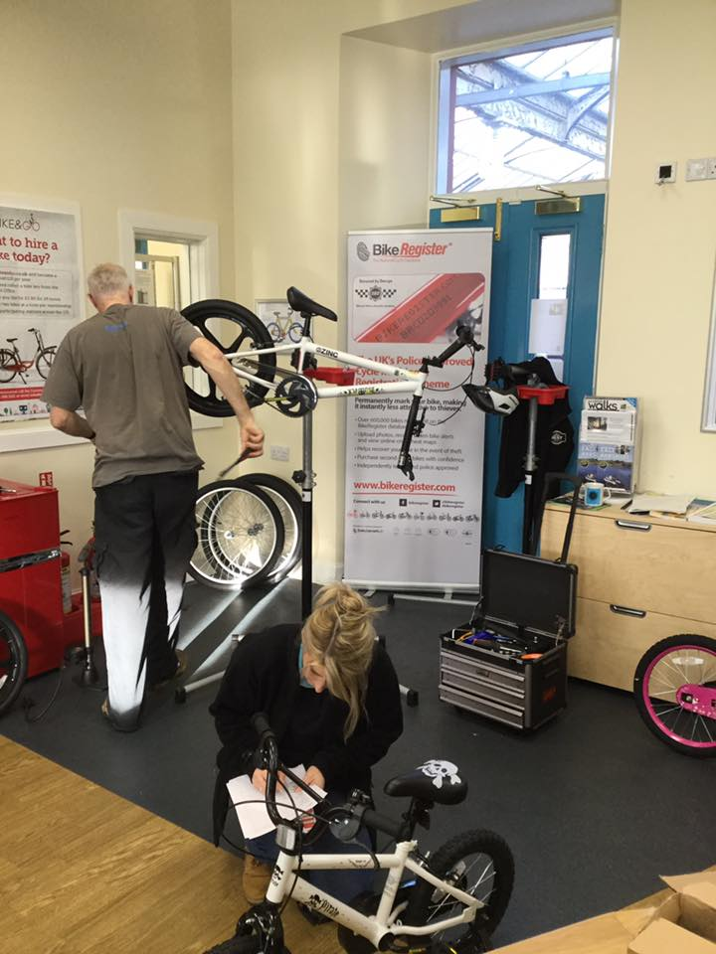
Photo of drop off/collection point:
Note: Bikes will be booked in for a specific time slot. There will be no overlapping of collection/drop off times to avoid unnecessary contact and allow physical distancing in this area. Bikes to be placed here by beneficiary and sanitised by PO or volunteer, then pushed into Hub for work to be completed. Pushed back out afterwards and re-sanitised ready for collection by beneficiary. One way system can be in place using both doors in the photo: in via door on left, out via door on right.
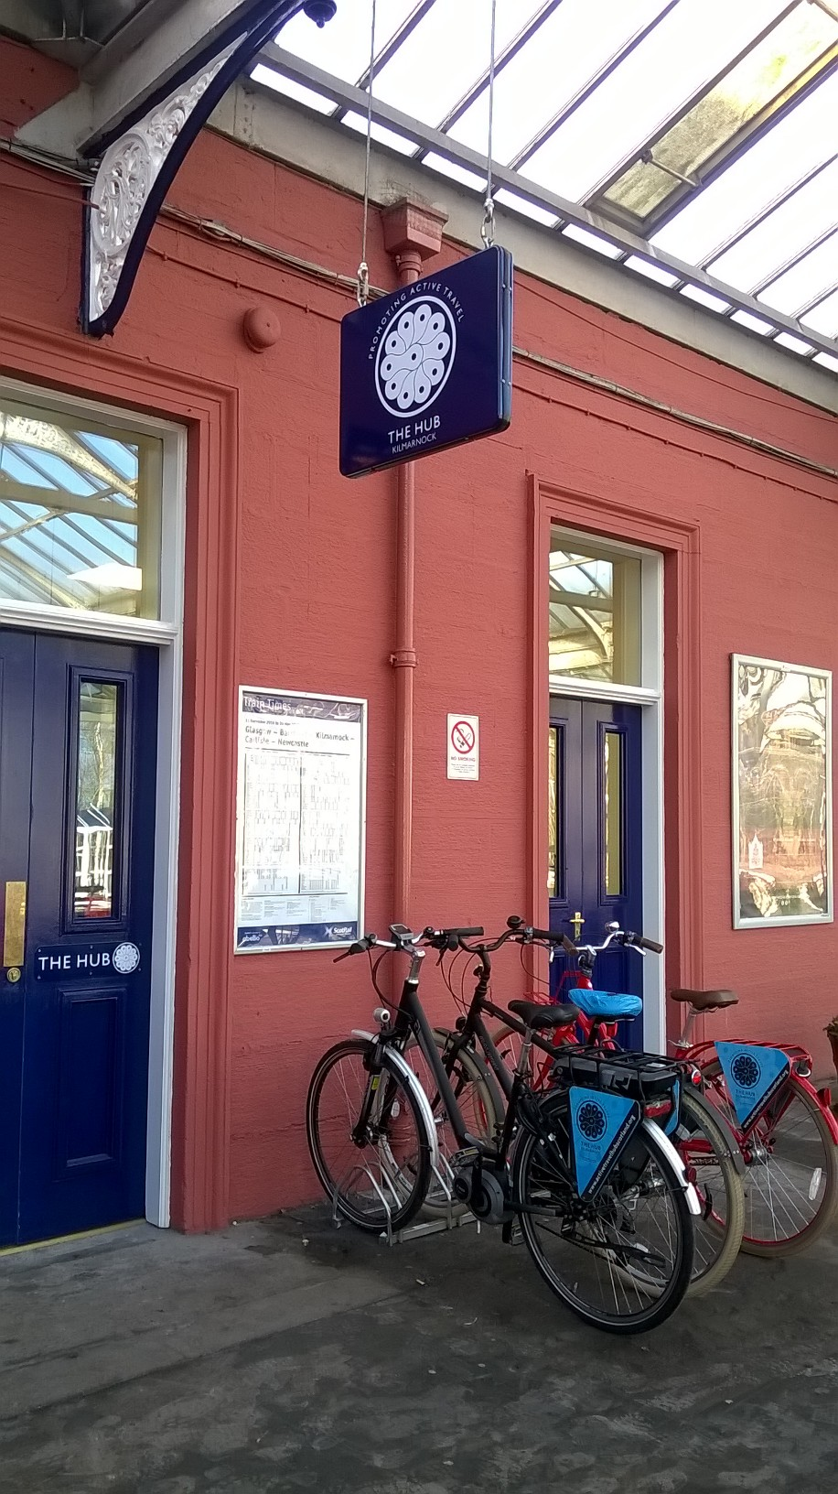

Event staff (one of the below Hub Officers + 1 volunteer)
Name | Role | Contact telephone number | Emergency contact number
Officer name | Active Travel Hub Officer | <officer phone number> | <officer emergency contact name and number>
Officer name | Active Travel Hub Officer | <officer phone number> | <officer emergency contact name and number>
Volunteer name | Hub volunteer | <volunteer phone number> | <volunteer emergency contact name and number>
John Walker | Hub volunteer | <volunteer phone number> | <volunteer emergency contact name and number>

Plan completed by
Name |  | Date

Plan reviewed by (manager/staff supervisor)
By implementing this plan, I am satisfied that the Health and Safety risks associated with the event will be reduced to an acceptable level.
Name |  | Date

Risk quantification model:

 | Severity (Se) rating
Probability (Pr) rating | Minor (1) | Serious (2) | Major (3)
Low, may happen (1) | 1 | 2 | 3
Medium, could happen (2) | 2 | 4 | 6
High, will happen (3) | 3 | 6 | 9

Risk categories:
Acceptable | Marginal | Moderate | Unacceptable

A. Risk quantification model:
A.1 The ‘risk quantification model’ provides an estimator that can be used to ensure a consistent approach is used for quantifying risks based on a simple matrix of ‘probability of occurrence’ and ‘severity of outcome’. In effect, risk equals probability multiplied by severity, Ri = Pr x Se.

Probability (Pr) that an event will occur.
Probability (Pr) | Rating | Criteria to consider in relation to the hazard being assessed
Low, may happen | 1 | Where harm will seldom occur.  A hazard is rarely approached and/or is infrequently present in the workplace, e.g. a less than 25% chance that the hazard will be experienced if, for example, the work was being undertaken for an 8-hour average working day.
Medium, could happen | 2 | Where harm will often occur.  A hazard is sometimes approached and/or is frequently present in the workplace, e.g. between a 25% and 75% chance that the hazard will be experienced if, for example, the work was being undertaken on for an 8-hour average working day.
High, will happen | 3 | Where it is certain that harm will occur.  A hazard is always approached and/or is permanently present in the workplace, e.g. a greater than 75% chance that the hazard will be experienced if, for example, the work was being undertaken for an 8-hour average working day.

Severity (Se) of the outcome if the event is realised.
Severity (Se) | Rating | Criteria to consider in relation to the hazard being assessed
Minor | 1 | Injuries that are unlikely to be reportable under RIDDOR, e.g. superficial or minor first-aid injuries such as minor cuts, bruises, eye irritation, nuisance skin irritation, transient or non-persistent coughing etc; and small fires with little or no disruption.
Serious | 2 | Injuries that are likely to be reportable as a >3-day injury under RIDDOR, such as lacerations, burns, strains and sprains, minor fractures to the fingers or toes, non-permanent work-related upper limb disorders, eye irritation, persistent coughing, nausea, breathing distress, dermatitis, chrome and other ulcerations; and minor fires causing transient disruption.
Major | 3 | Injuries that are likely to be reportable as major injuries under RIDDOR, such as fatalities, amputations, major fractures, multiple injuries, permanent work-related upper limb disorders, poisonings, permanent or semi-permanent blindness, occupational cancers, acute or severely life-shortening diseases, occupational asthma, etc; and fires causing significant disruption and/or major loss to or destruction of property or premises.

A.2 The following explains the typical actions required to manage different risks categories. In simple terms, the higher the risk category, the greater the potential for a serious incident, injury or fire and, consequently, greater controls are required.

(i) An unacceptable (or high) risk, a risk rating of 9.
Such risks in the workplace are unacceptable and work should not commence. If work is in progress, it must be stopped immediately until such actions are taken as to reduce or control the risk to an acceptable level. Temporary controls, except in an emergency situation would not be sufficient to justify work commencing or continuing. Risk reduction plans should be documented and fully implemented before recommencing work.

(ii) A moderate risk, a risk rating of 6.
Such risks are unacceptable and work should not commence. If work is already in progress, it should be suspended until such actions are taken as to reduce or control the risks. This could include the use of temporary control measures until a permanent solution is implemented. Existing controls require careful management and supervision to ensure their effective implementation. A written action plan should be developed to further reduce or control the risks.

(iii) A marginal risk, a risk rating of 3 or 4.
Such workplace risks are tolerable and, generally, work can commence or continue. However, if appropriate, a written action plan should be developed to further reduce or control the risks to a more acceptable level. The existing control measures are generally appropriate to control or manage the risks, but require on-going management supervision, such as by an audit, to ensure their continuous implementation.

(iv) An acceptable (or low) risk, a risk rating of 1 or 2.
Such risks are, generally, seen as being acceptable without any specific workplace controls being required. Any existing controls are appropriate to manage the risks. Management supervision and employee training are required to ensure the existing controls, including the use of personal protective equipment (PPE), are implemented.

