|  |
| --- |
| Led Ride Risk Assessment and Plan |

This risk assessment addresses the specific hazards associated with this led ride. Generic risk assessment RA26 (Bike Rides) identifies and informs the standard operating requirements for planning and managing led rides. RA26 is available on the H&S pages of Susnet and Volunteernet.

|  |  |  |  |  |  |
| --- | --- | --- | --- | --- | --- |
| Ride/route description | Group led Ride  Example to show completion of RA template.  Short beginners led ride on traffic free cycle route | Ride date(s) | Record planned repeat rides | | |
| Start location | Alfred Street | End Location | Belfast Met, Titanic Quarter | | |
| Length of ride (distance) | 2.2 miles | Timings | Start | End | Duration |
| : | : | : |

Please tick boxes which best describe your ride:

|  |  |  |  |  |  |  |  |  |
| --- | --- | --- | --- | --- | --- | --- | --- | --- |
| Group | Adult only | ✓ | Family Group |  | Children only |  |  |  |
| Experience levels of participants | Novice | ✓ | Intermediate |  | Experienced |  |  |  |
| Route type | Traffic free (including roadside footpaths) |  | Mainly traffic free with roads crossings or short sections of quiet roads | ✓ | Quiet roads without footpaths |  | Busy or higher risk routes or sections **\*** |  |

* Details of these sections and the proposed management to be included overleaf. This should include busy or faster traffic levels, complicated sections, railway crossings, adjacent to deep water etc.

|  |  |  |  |
| --- | --- | --- | --- |
| Nearest A&E Hospital | Mater Hospital | Nearest defibrillator  (if known) |  |

|  |
| --- |
| **Sustrans out of hours emergency telephone number <number>** |

|  |  |  |  |  |
| --- | --- | --- | --- | --- |
| **Led ride team** | | | | |
| Name | Role | Contact telephone number | Training requirements/competence checked | Tick Y/N |
|  | Ride Manager |  |  |  |
|  | Ride Leader |  |  |  |
|  | Ride Assistant |  |  |  |
|  | First Aider |  |  |  |
|  | Mechanic |  |  |  |
|  | Other |  |  |  |

Insert a map of the route annotated with identified route hazards and the control measures to be implemented. Include any other relevant information relevant to this ride (e.g. rest stops, cafes etc.).

Led ride group of up to 10 Adults using Belfast bikes on 2.2 mile one way trip all traffic free using on road cycle lanes and cycle routes with some crossings the route will be from the Belfast Bikes stand on Alfred Street to the Belfast Bikes stand opposite the Belfast Met (not crossing Queens Road as marking on map suggests). The riders and their ability are not known to ride staff but they have been asked that they are able to ride.

Three ride staff

<Ride manager name> trained ride manager will be at side to help with crossings and will carry first aid kit and basic maintenance kit.

<Ride leader name> trained ride manager will lead the ride keeping to the route and at a pace to suit slowest rider

<Ride assistant name> experienced with Sustrans led rides will be at the back to support riders and watch for any falling behind

There will be a short ride briefing at the start, covering basics of led ride, stay with the group follow ride leader don't go ahead or behind ride cross together and also rules of shared path.

Crossings will be made as a whole group unless circumstances require splitting e.g. using small traffic island. Stops as crossings will be a chance to monitor group and stop for water etc., if necessary.

Bikes will be Belfast bikes for most of group will be provided

Brakes, tyres and saddle height checked and adjusted.

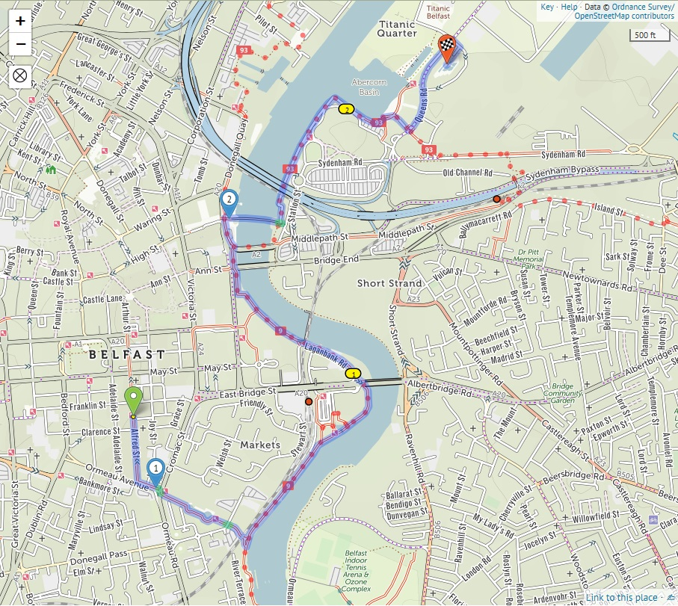

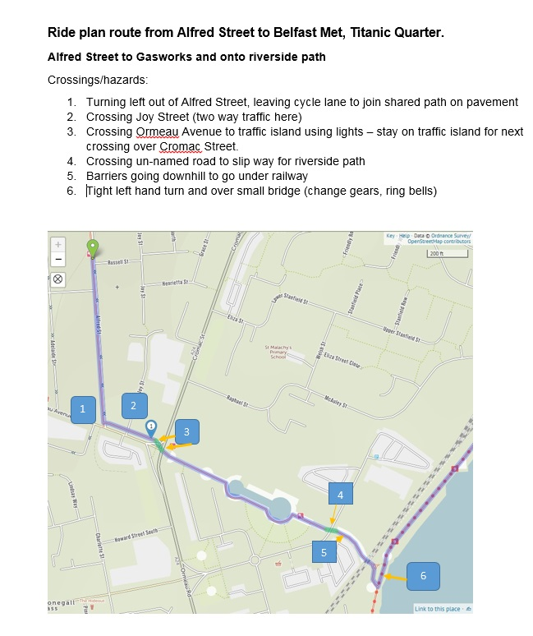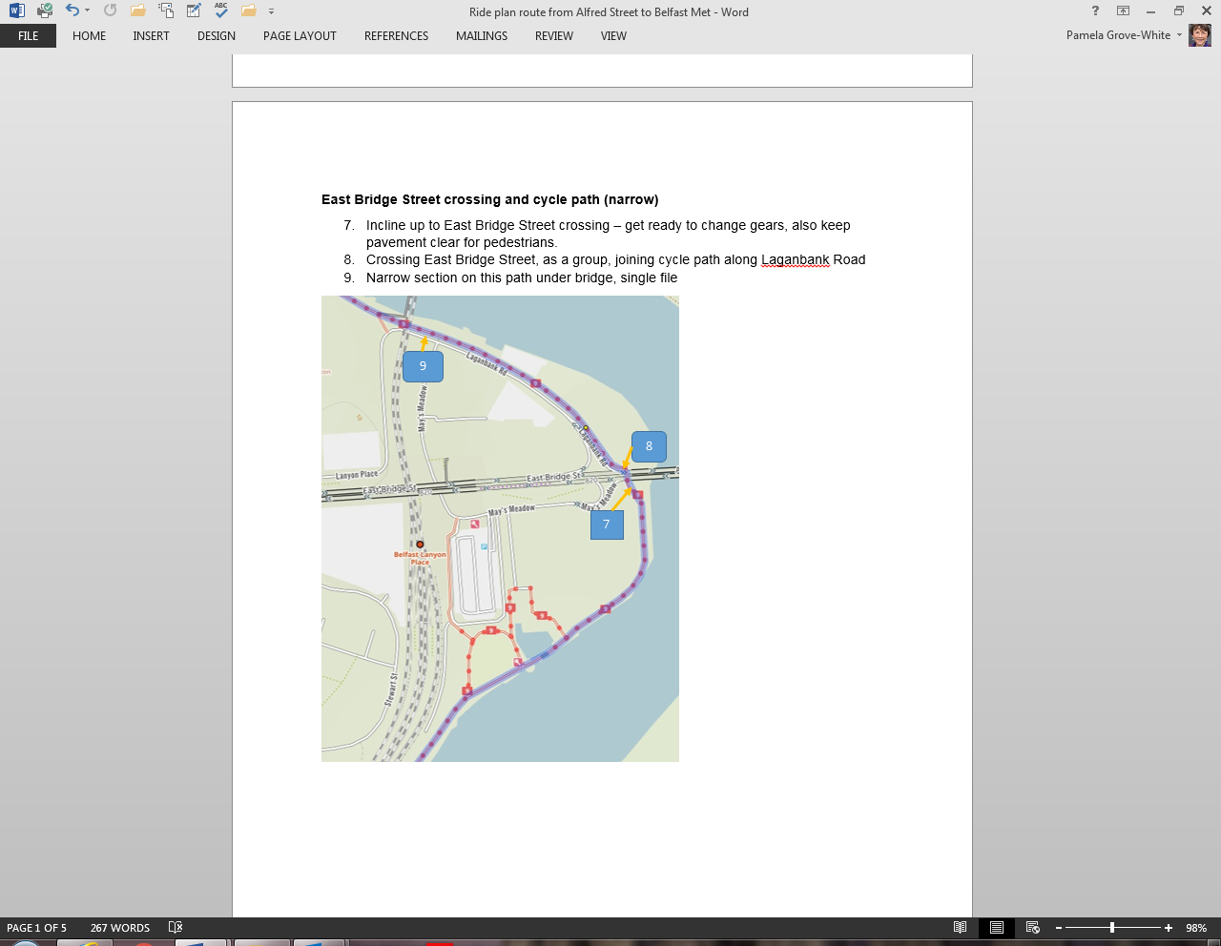

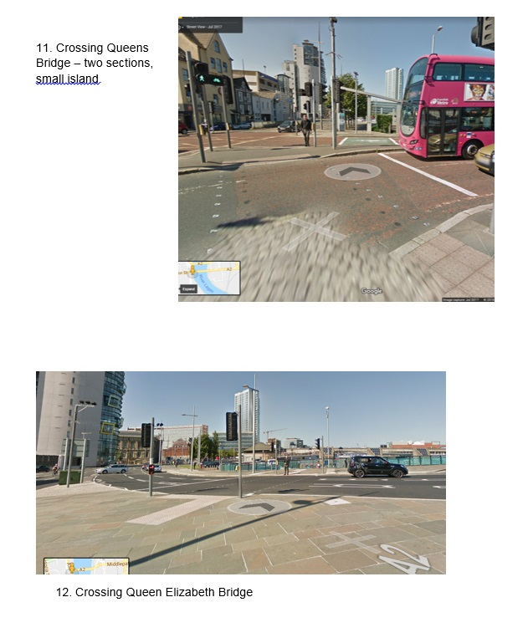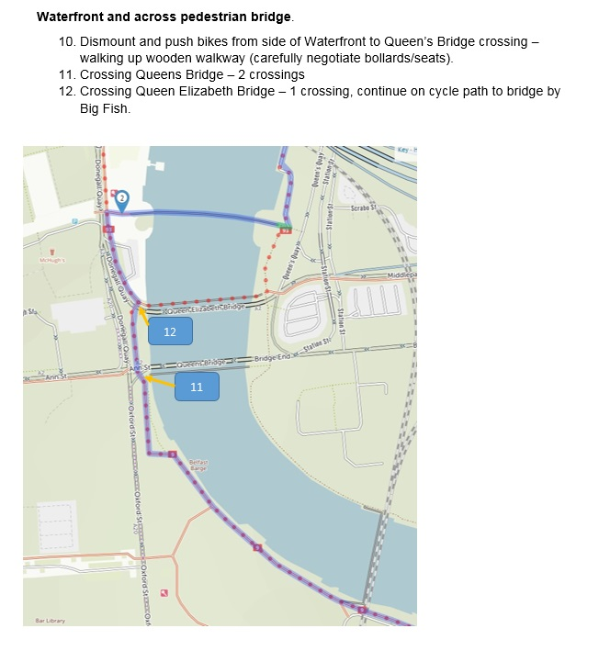

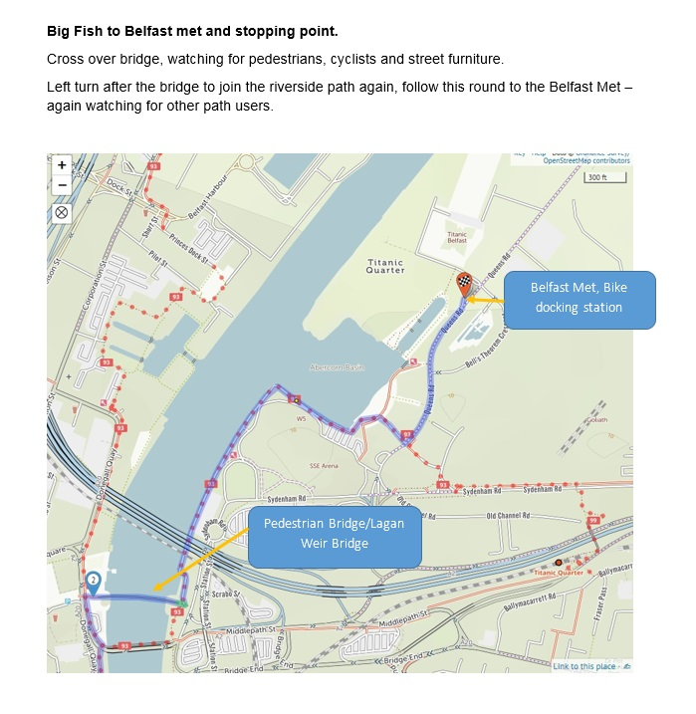

Uncommon route hazards identified and control measures to be implemented (refer to route map).

|  |  |  |  |  |  |
| --- | --- | --- | --- | --- | --- |
| **Location** | **Hazard** | **Additional controls to be implemented** | **\*Risk Rating** | | |
| **P** | **S** | **R** |
| 1 Alfred street | Crossing Alfred street from cycle lane to shared path – one way road, traffic from main road into Alfred St. | Group will stop at top of cycle path ready to cross.  Road crossings will be completed as one group where possible. Group led by ride leader with ride staff at the back. Ride manager will come to front of ride and move into the road when safe and group will then cross. Ride manager on right hand side of group. | 1 | 2 | 2 |
| 2. Joy Street | Crossing Joy Street continuing on shared path – two way road | Group will stop on pavement ready to cross. Crossing will be done as before, taking into account traffic will be coming from both directions | 1 | 2 | 2 |
| 3. Cromac Street | Crossing Ormeau Avenue and Cromac Street using signalled crossings | Crossing as above, if the group is more than 6 it will be split into two to enable each section to safely wait on the traffic island. The first group will be led by the ride leader, the second group will be led by the back marker with the ride manager on the road for each crossing. The first group will wait at the gasworks in a safe place for the second group to cross. | 1 | 2 | 2 |
| 4. un-named road in gasworks | Crossing road – two way to slip way | Crossing as usual, this is not a signalled crossing and there is a bend in the road, but the group will be asked to get ready to cross and cross together in the same manner as others, ride manager on right hand side of group. | 1 | 2 | 2 |
| 5. slipway in gasworks | Uneven surface and barriers going down | Riders reminded of barriers, keep speed slow and watch for barriers and uneven surface – single file | 1 | 2 | 2 |
| 6. onto riverside path | left turn up and over bridge | Riders reminded be ready to go up hill and to left, single file, changing gears and ringing bells, ride manager to go up to main path to watch for other path users. | 1 | 2 | 2 |
| 7. East Bridge Street | Incline up to crossing and keeping path clear for pedestrians | Riders reminded to prepare for small hill and asked to position themselves so path users can get past. | 1 | 2 | 2 |
| 8. Albert Bridge | Road crossing joining cycle path | Crossing at signalled crossing, group to cross as one as with other crossings. | 1 | 2 | 2 |
| 9. laganbank road cycle path | Narrow path, | Keep in single file | 1 | 2 | 2 |
| 10. cycle path at waterfront | Cycle path blocked | Need to dismount and walk bikes round diversion | 1 | 2 | 2 |
| 11. Queens Bridge | Crossing using signals – two parts to crossing with small island. | May need to cross in two groups if not enough room on island, in this case first group will be led across by ride leader and will wait at a safe spot for second group to follow, ride manager will stay on road for each crossing. | 1 | 2 | 2 |
| 12. Queen Elizabeth Bridge | Crossing – using signals | AS with other crossings, stay as one group to re-join cycle path. | 1 | 2 | 2 |
| Contingency arrangements | | | | | |
|  | | | | | |

**\*Residual risk after controls are implemented - Probability (P), Severity (S), Risk (R), PxS=R.**

You should reduce residual risk ratings to as low as is reasonably practicable. If your residual risk rating is greater than four you will need to introduce further controls to bring the risks down to an acceptable level. Marginal risks (2 – 4) will require a higher level of monitoring to ensure that they remain acceptable. The Sustrans Risk Quantification Model is at the end of this document and further information can be found in Risk Assessment Procedure (H&S/PRO/02).

|  |  |  |  |
| --- | --- | --- | --- |
| **Assessment and plan completed by** | | | |
| **Name** |  | **Date** |  |
| **Approval** | | | |
| By implementing this plan, I am satisfied that the Health and Safety risks associated with the event will be reduced to an acceptable level and that ride management team has the necessary competence to deliver this ride safely and in accordance with the ride standard. | | | |
| **Name** |  | **Date** |  |

**Led ride planning checklist**

|  |
| --- |
| **Advance planning requirements** |
| * The route been ridden beforehand to identify exceptional hazards and controls * The extent and difficulty of the ride is suitable for all participants. * Permissions and licences have been obtained from land owners and local authorities etc. * Appropriate Ride Staff support ratios have been identified * Ride staff and participant briefing prepared * Participants who require additional support identified and appropriate arrangements are in place * Organised event notification form (for large or unusual events) has been submitted if required * Ride requirements including what they need to bring on the day has been communicated * Emergency planning procedure arrangements are in place * The Risk Assessment and Plan has been approved * The weather forecast has been checked |
| **On the day, pre-ride requirements** |
| * Participant register is completed * Written consent obtained for children, young persons and vulnerable adults to participate. This may include if applicable, consent not to wear a helmet and/or high visibility clothing from the parent or another organisation that is acting in loco parentis * Pre-ride checks conducted, including rider ability, bike suitability, M-check, clothing and helmet check * Ride Staff briefing delivered * Participant briefing delivered |
| **Post ride requirements** |
| * Any incidents and significant near misses are reported, including those which involve members of the public * Feedback gathered from participants and used to evaluate future led ride plans |

**The Sustrans Risk Quantification Model**

|  |  |  |  |  |  |  |  |  |
| --- | --- | --- | --- | --- | --- | --- | --- | --- |
|  | | | | Severity (S) rating | | | | |
| Probability (P) rating | | Minor (1) | | | Serious (2) | | Major (3) | |
| Low, may happen (1) | | 1 | | | 2 | | 3 | |
| Medium, could happen (2) | | 2 | | | 4 | | **6** | |
| High, will happen (3) | | 3 | | | **6** | | **9** | |
| Risk categories: | | | | | | | | |
| Acceptable | | Marginal | | | **Moderate** | | **Unacceptable** | |